Real-Time Pothole Detection and Mapping System for Smart Vehicles Using YOLOv8

Dharma Teja Garipally (22BCE8224) , Kowshik Annam (22BCE8333) , Ambati Sharanya Reddy (22BCE8396) , and Polisetti Govardhini (22BCE8163).

Computer Science and Engineering, Vellore Institute of Technology Amaravati, Andhra Pradesh, India [info@vitap.ac.in](mailto:info@vitap.ac.in)

https://vitap.ac.in

**Abstract**:

This project aims to develop a system for automated and accurate pothole detection to improve road safety and maintenance efficiency. Potholes are a widespread issue that significantly impact road infrastructure, causing accidents, vehicle damage, and escalating repair costs. The current method of pothole detection, which relies on manual inspections, is labor-intensive, slow, and results in delays in repairs, leading to extended exposure to unsafe road conditions. Motivated by the limitations of traditional approaches, we plan to utilize advanced technologies such as image processing, machine learning, and deep learning algorithms to automate the detection of potholes. By employing these techniques, we aim to enhance accuracy, reduce the time for identification, and ultimately improve the overall road maintenance process, ensuring safer roads and efficient resource allocation for repairs.

Keywords: Pothole detection, Deep Learning Architectures, YOLO, TensorFlow, Roboflow.

**Introduction**:

**Purpose**

The purpose of this project is to develop an automated system that detects and maps potholes in real-time using YOLOv8, a deep learning model designed for fast and accurate object detection. The system is intended to enhance road safety, improve vehicle longevity, and streamline road maintenance processes by notifying authorities about pothole locations.

**Scope**

The system will focus on real-time detection of potholes from vehicle-mounted cameras, providing a geographical map of the detected potholes. It will be applicable to all road types and adaptable to different weather and lighting conditions, ensuring scalability across urban and rural environments.

**Data Set:**

In this study, we use two extensive datasets for pothole detection. The first dataset includes over 1500 annotated images from Roboflow and an additional 1000 images sourced from various online platforms. The second dataset features over 1500 images captured from car dashboards and other sources, providing realistic road conditions from a driver’s perspective. Combined, these datasets total more than 3000 images, encompassing a wide range of scenarios and conditions. This diverse collection is instrumental for training and validating robust pothole detection models, ensuring comprehensive coverage and accuracy.

# Problem Statement:

# Potholes are a common issue on roads worldwide, leading to significant safety hazards for drivers and passengers alike. They contribute to accidents, vehicle damage, and increase the cost of road maintenance. Traditional methods of detecting potholes rely heavily on manual inspections, which are labor-intensive, time-consuming, and often result in delayed repairs. The inefficiencies in current practices lead to prolonged exposure to dangerous road conditions, making it imperative to develop a more effective solution.

# **Proposed Solution:**

This project proposes the development of an automated pothole detection system using the advanced YOLOv8 (You Only Look Once version 8) deep learning model. YOLOv8 is renowned for its speed and accuracy in object detection tasks, making it an ideal choice for real-time pothole identification. The system will be designed to process video feeds or images captured by cameras mounted on vehicles or roadside infrastructure, identifying and localizing potholes with high precision. The detected potholes will be marked and their coordinates will be recorded on a digital map, enabling quick response and targeted road maintenance efforts

# Expected Outcomes:

* A fully operational pothole detection system capable of identifying and localizing potholes in real-time.
* A comprehensive mapping of detected potholes, allowing road maintenance teams to prioritize repairs based on severity and location.
* A reduction in road accidents and vehicle damage caused by potholes, leading to enhanced public safety and lower vehicle maintenance costs.
* A streamlined process for road monitoring and maintenance, reducing the time and resources needed for manual inspections.

**Requirement Analysis for the Pothole Detection System**

**1.Functional Requirements:**

- **Real-Time Pothole Detection:** The system must detect potholes in real-time using YOLOv8. It should be capable of processing video streams from vehicle-mounted cameras or other sources to identify and localize potholes.

- **Pothole Localization and Mapping:** The system should provide the exact geolocation (latitude and longitude) of detected potholes and mark them on a digital map. This mapping will assist road maintenance teams in identifying and prioritizing repairs.

- **Data Acquisition and Preprocessing:** The system will collect images or video data of roads, which will be preprocessed and fed into the YOLOv8 model. The preprocessing will involve tasks such as noise reduction, resizing, and image augmentation.

- **Classification and Reporting:** The detected potholes should be categorized based on size or severity, and the system should generate periodic reports for road maintenance authorities. The system must also have the capability to notify users of newly detected potholes in specific locations.

**2. Non-Functional Requirements:**

- **Performance:** The system should have low latency to ensure real-time pothole detection. It should be optimized for speed, ensuring minimal impact on vehicle performance and road monitoring systems.

- **Accuracy:** The detection system should maintain a high level of accuracy, with an acceptable false-positive rate, especially under various weather and lighting conditions.

- **Scalability:** The system should be scalable to process large datasets and multiple video streams simultaneously, making it suitable for deployment across multiple vehicles or road monitoring systems in large cities.

- **Usability:** The interface for displaying pothole locations and generating reports should be user-friendly, allowing road maintenance teams to easily interpret the data.

- **Reliability:** The system must be reliable and capable of functioning in diverse environmental conditions, including different weather scenarios and road conditions.

- **Security:** The system should ensure that the data related to pothole detection, especially location-based information, is protected against unauthorized access and tampering.

#### ****3. User Requirements****

1. **Ease of Use:**

The system should have an intuitive user interface, allowing easy access for drivers and maintenance teams.

1. **Mobile Accessibility:**

The system should be accessible via mobile devices for maintenance crews in the field.

1. **Report Customization:**

Users should be able to customize reports by filtering based on time, location, or severity of potholes.

#### ****System Architecture****

****1.Modular Design:****

The system will follow a modular architecture, with separate components for video processing, detection, mapping, and reporting.

****2.Data Management:****

All detected potholes will be stored in a central database, with each entry containing location, time, and severity data. The system will include a backup solution to ensure data reliability.

****3.Algorithm Design:****

The YOLOv8 model will be fine-tuned on a diverse dataset to optimize pothole detection accuracy across various road conditions.

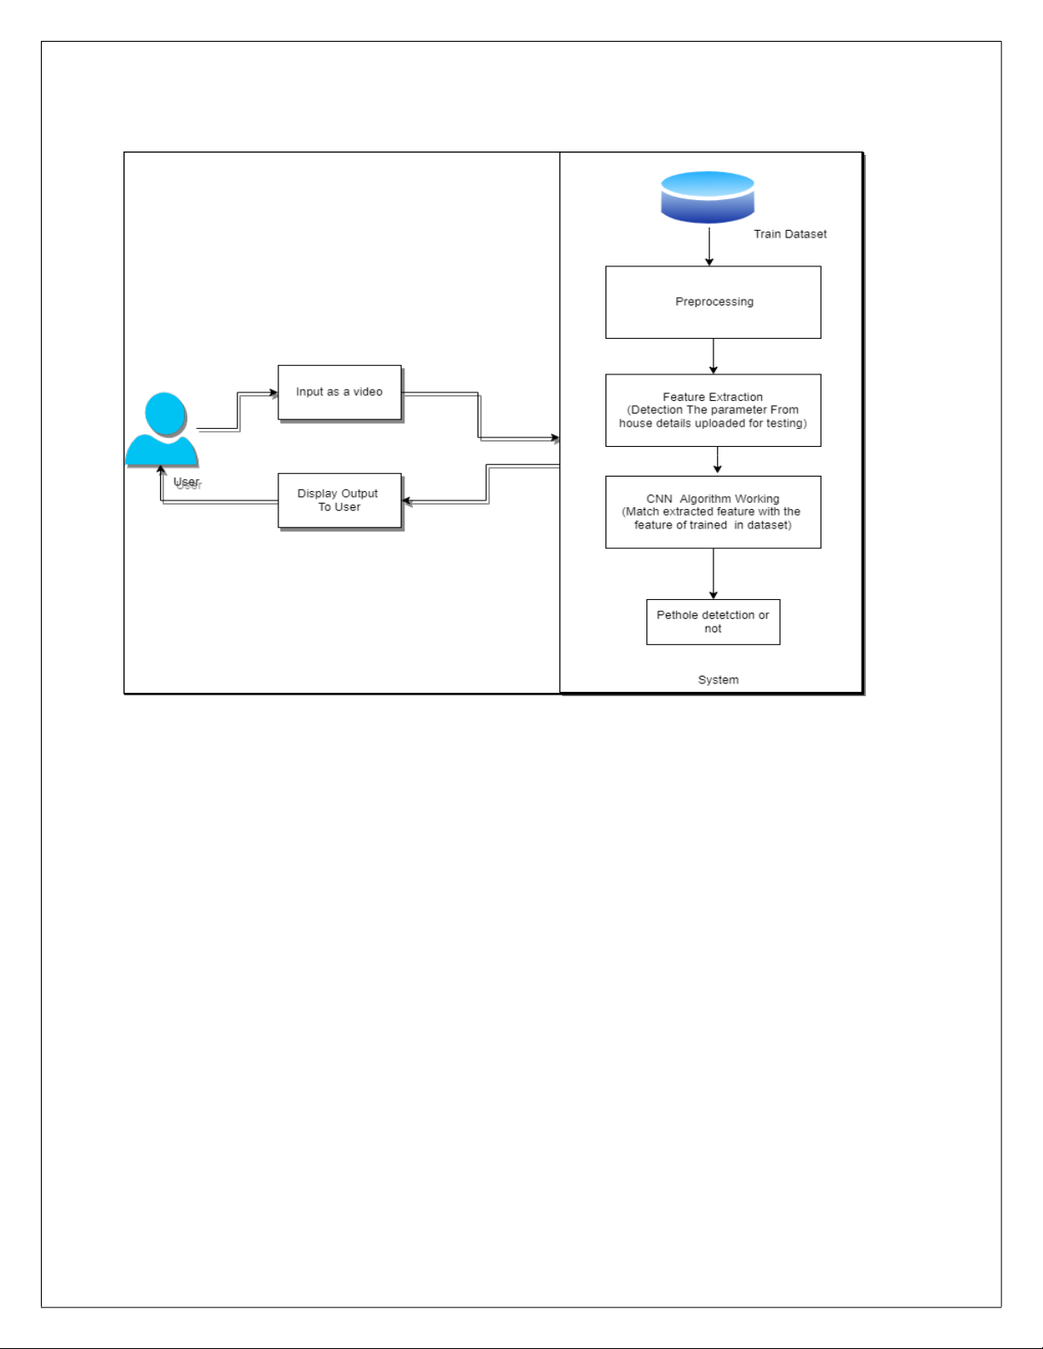

#### ****Development and Deployment****

**1.Development Environment**

The system will be developed using Python for machine learning components, with YOLOv8 as the core detection algorithm. JavaScript and HTML will be used for the user interface.

1. **Deployment Strategy**

The system will be deployed as a cloud-based solution, ensuring that it is accessible from anywhere. Mobile apps for both iOS and Android will also be developed for maintenance crews.

#### ****Testing and Validation****

1. **Testing Approach**

Unit tests will be conducted to ensure each module functions correctly, including video processing, detection, and mapping. The overall system will be tested under various conditions (e.g., weather, lighting) to ensure robustness.

1. **Validation**

The accuracy of YOLOv8's detection will be validated using a test dataset. Metrics such as precision, recall, and mAP (mean Average Precision) will be used to assess the model's performance.

**Literature Survey on Pothole Detection System**

**Paper 1: "Pothole Detection Using Deep Learning and Road Surface Images"**

**Authors**: K. Sivaraman, M. Trivedi

**Published In**: IEEE Transactions on Intelligent Transportation Systems, 2020

* **Problem Statement:** Potholes present a significant hazard to road safety. Manual inspection methods for detecting and fixing potholes are slow and inefficient, particularly on long stretches of road. The challenge is to create an automated system that can identify potholes in real-time using visual inputs and reduce the cost and time for road inspection.
* **Proposed Solution:** The authors propose a computer vision-based pothole detection system using deep learning. The system leverages a **YOLOv3 deep neural network** to identify potholes in images captured by cameras mounted on vehicles.
* **Algorithm and Methodology:**
  + The authors use **YOLOv3** (You Only Look Once), a deep learning-based object detection algorithm, to detect potholes in images.
  + YOLOv3 works by dividing the image into grids and predicting bounding boxes and class probabilities directly from the image in a single pass, allowing for real-time detection.

**Paper 2: "Mobile Crowdsensing for Road Pothole Detection Using Smartphones"**

**Authors**: D. Mednis, G. Strazdins, R. Zviedris

**Published In**: International Conference on Distributed Computing in Sensor Systems (DCOSS), 2019

* **Problem Statement:** Smartphones, with built-in accelerometers and GPS, have the potential to detect road anomalies. However, distinguishing between potholes and other road irregularities, such as speed bumps, remains a challenge. The key issue is how to use sensor data effectively to identify potholes and avoid false positives.
* **Proposed Solution:** The authors propose a **crowdsourcing-based approach** using smartphone sensors (accelerometers and GPS) to detect potholes. The system is designed to identify potholes based on the patterns in sensor data when a vehicle hits a pothole.
* **Algorithm and Methodology:**
  + The system uses a **rule-based algorithm** to detect sudden vertical accelerations that exceed a certain threshold, which typically indicate the presence of a pothole.
  + **GPS data** is used to log the location of the detected pothole. Data is collected from the smartphone’s accelerometer and gyroscope as the vehicle moves over different road surfaces. Multiple detections from different smartphones are aggregated to confirm the existence of a pothole, reducing false positives.

**Paper 3: "Real-Time Pothole Detection Using LiDAR and Image Fusion"**

**Authors**: H. Zhang, W. Liu, Z. Zhang

**Published In**: Journal of Advanced Transportation, 2021

* **Problem Statement:** Detecting potholes accurately in various lighting and weather conditions is a challenge. While image-based methods can fail under poor lighting or heavy traffic, LiDAR can provide a robust way to measure road surface irregularities. The challenge is to fuse these different modalities for more reliable detection.
* **Proposed Solution:** The paper proposes a **fusion-based approach** that combines **LiDAR** and **camera images** to improve the accuracy of pothole detection under various environmental conditions.
* **Algorithm and Methodology:**
  + A **convolutional neural network (CNN)** is used to analyze the image data, while a **LiDAR-based surface height analysis** identifies height variations in the road surface.
  + The CNN detects visual anomalies, while LiDAR detects 3D surface irregularities. A **fusion algorithm** combines these two modalities to confirm the presence of a pothole.
  + The fusion process uses **Kalman filters** to integrate the two data streams, allowing for more robust detection even in poor lighting or adverse weather.

**Paper 4: "Automatic Pothole Detection Using Machine Learning on Accelerometer Data"**

**Authors**: M. Eriksson, N. Mohan

**Published In**: IEEE Sensors Journal, 2020

* **Problem Statement:** A major challenge in using accelerometer data to detect potholes is distinguishing between different road anomalies and the variability of vehicle speeds. A reliable detection algorithm needs to work in real-world conditions with minimal false positives.
* **Proposed Solution:** This paper proposes a **machine learning-based approach** to detect potholes from smartphone accelerometer data. The system uses a supervised learning model trained on labeled accelerometer data to differentiate between potholes, speed bumps, and other road anomalies.
* **Algorithm and Methodology:**
  + The authors use a **Support Vector Machine (SVM)** to classify each window of accelerometer data as either a pothole, speed bump, or normal road surface.
  + The features used for classification include **maximum acceleration**, **signal energy**, and **peak-to-peak interval**.
  + Accelerometer data is collected from multiple vehicles driving over different road surfaces. The data is then segmented into windows corresponding to individual road events. GPS coordinates from the phone are used to log the location of detected potholes and share the data with a centralized database for road maintenance.

**Paper 5: "Pothole Detection Using Hybrid SVM and Texture Analysis on Road Images"**

**Authors**: A. Rashid, P. Khan

**Published In**: International Journal of Computer Vision, 2018

* **Problem Statement:** Detecting potholes using image data is a well-known approach, but distinguishing potholes from other road defects such as cracks and patchwork presents challenges. This paper addresses the need for a more precise classification of road defects, especially in varying road conditions.
* **Proposed Solution:** The authors propose a **hybrid method** combining **SVM (Support Vector Machines)** and **texture analysis** to detect and classify potholes in road images. The hybrid system improves the accuracy of pothole detection by focusing on texture and shape features.
* **Algorithm and Methodology:**
  + The system first performs **edge detection** using the **Canny edge detector** to isolate potential road defects.
  + The extracted regions are analyzed using **texture features** (e.g., **Local Binary Patterns (LBP)**) to classify them as potholes or other defects.
  + A **Support Vector Machine (SVM)** is then used to classify the regions based on their texture and shape.
  + Images of road surfaces are collected using a high-resolution camera mounted on a vehicle. The images are converted to grayscale, and noise is reduced using a **Gaussian filter**.
  + False positives are filtered by analyzing the shape of the detected regions (e.g., potholes tend to be circular or irregular, while cracks are linear).

|  |  |  |  |
| --- | --- | --- | --- |
| **S.NO** | **Research paper links** | **Methodology** | **Limitations** |
| 1 | <https://ieeexplore.ieee.org/stamp/stamp.jsp?tp=&arnumber=10505438> | The paper improves pothole detection using **YOLOv5-Seg** enabling better localization and detection of potholes. The authors fine-tune the model by adjusting anchor box sizes and incorporating a feature pyramid network to handle multi-scale objects. Additionally, they enhance training by using a custom dataset of road images with annotated potholes, optimizing the model for real-world road conditions. | The model’s performance is affected by environmental factors such as poor lighting, heavy shadows, and adverse weather conditions (e.g., rain or snow). It also struggles with detecting smaller, less prominent potholes, and requires further optimization to reduce computational costs for real-time detection in resource-constrained devices like in-car systems. |
| 2 | <https://ieeexplore.ieee.org/stamp/stamp.jsp?tp=&arnumber=9266138> | The paper employs **computer vision techniques** to detect potholes in road images using a combination of image processing methods like **edge detection**, **morphological operations**, and **contour analysis** to identify and classify road anomalies. | The method struggles in challenging conditions such as low lighting, poor weather, or when road surfaces are cluttered with debris or shadows. It also faces difficulties in differentiating between potholes and other road surface anomalies like cracks or patches. |
| 3 | <https://ieeexplore.ieee.org/stamp/stamp.jsp?tp=&arnumber=10458751> | The paper proposes a **smartphone-based pothole detection system** that uses the phone's **accelerometer and gyroscope sensors** to identify road irregularities in real-time, providing alerts to the driver about potential potholes ahead. | The system may generate false positives due to sudden braking, speed bumps, or sharp turns. Detection accuracy can also vary based on smartphone sensor sensitivity and the position of the phone in the vehicle. |
| 4 | PotholedetectionwithYOLOV8.pdf | The paper explores the use of **YOLOv8**, a state-of-the-art real-time object detection model, for detecting potholes in road images and videos. YOLOv8 processes frames using a single forward pass through the neural network, making it highly efficient for real-time applications, and achieves high precision in identifying potholes of varying shapes and sizes. | The model’s performance can degrade under poor lighting, weather conditions like rain or fog, or when the road has occlusions such as debris or other anomalies. Additionally, it requires high computational resources for processing on low-latency systems, especially in real-time scenarios. |
| 5 | <https://onlinelibrary.wiley.com/doi/epdf/10.1155/2022/9221211> | This paper proposes a **deep learning-based pothole detection system** that leverages AI-on-the-edge devices. The system processes video frames in real-time using convolutional neural networks (CNNs) on **edge computing devices** (e.g., Raspberry Pi, NVIDIA Jetson). It aims to achieve real-time pothole detection without depending on cloud infrastructure, reducing latency and improving data privacy. | The system is constrained by the limited computational power of edge devices, which can affect detection accuracy and processing speed when dealing with complex road conditions. Additionally, edge devices are sensitive to environmental factors like extreme heat or dust, which can impact their reliability in outdoor deployments. |
| 6 | <https://www.nature.com/articles/s41598-024-52426-4> | The paper explores the use of **Vision Transformers (ViT)**, a transformer-based architecture traditionally used in natural language processing (NLP), for pothole and traffic sign detection. The ViT model processes image data by splitting it into patches, applying self-attention mechanisms, and classifying the potholes and traffic signs in the images with high accuracy. | Although Vision Transformers provide improved accuracy and performance over traditional convolutional neural networks (CNNs), they require a large amount of training data and high computational resources. In addition, ViTs are sensitive to image quality, meaning that performance may degrade under conditions such as poor lighting or obstructions on the road surface. |

**UML Diagrams:**

1. **Use Case Diagram:**

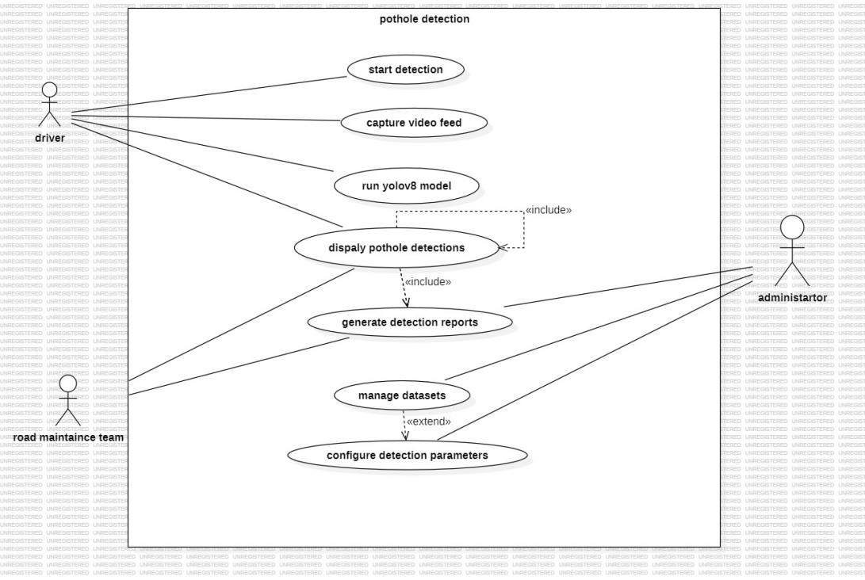

1. **Class Diagram:**

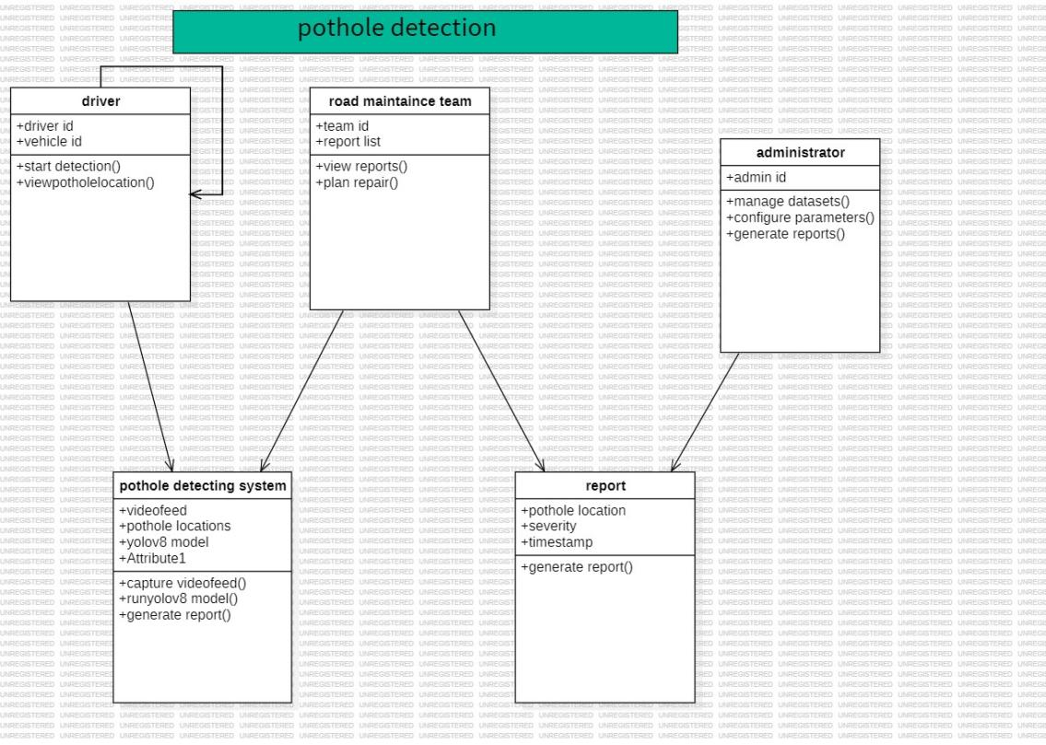

1. **Activity Diagram:**

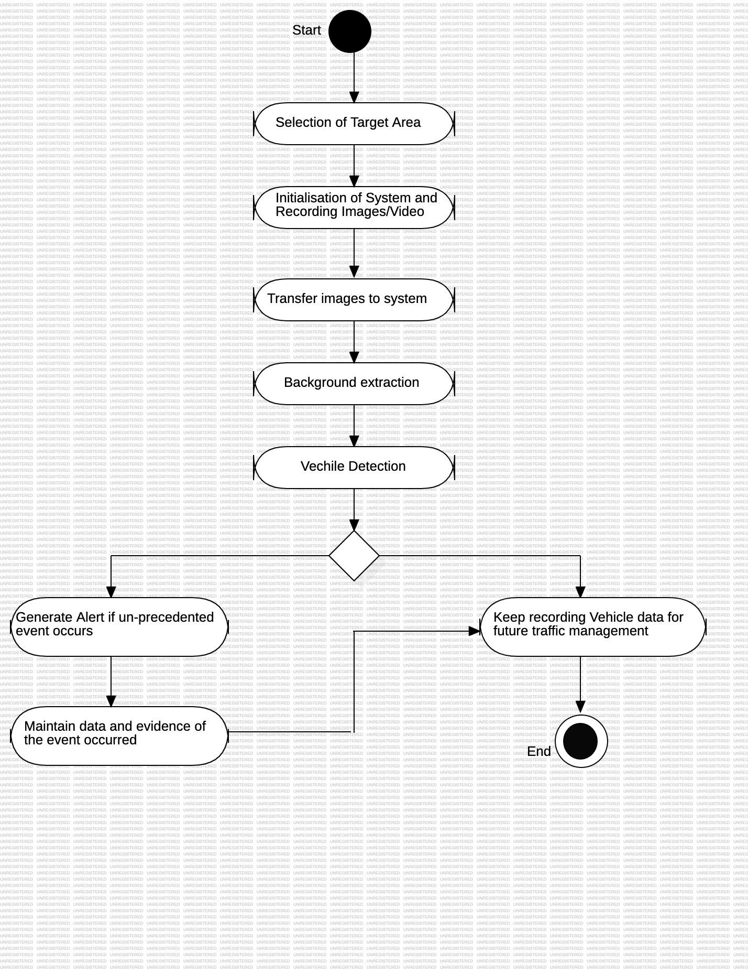

1. **State Diagram:**

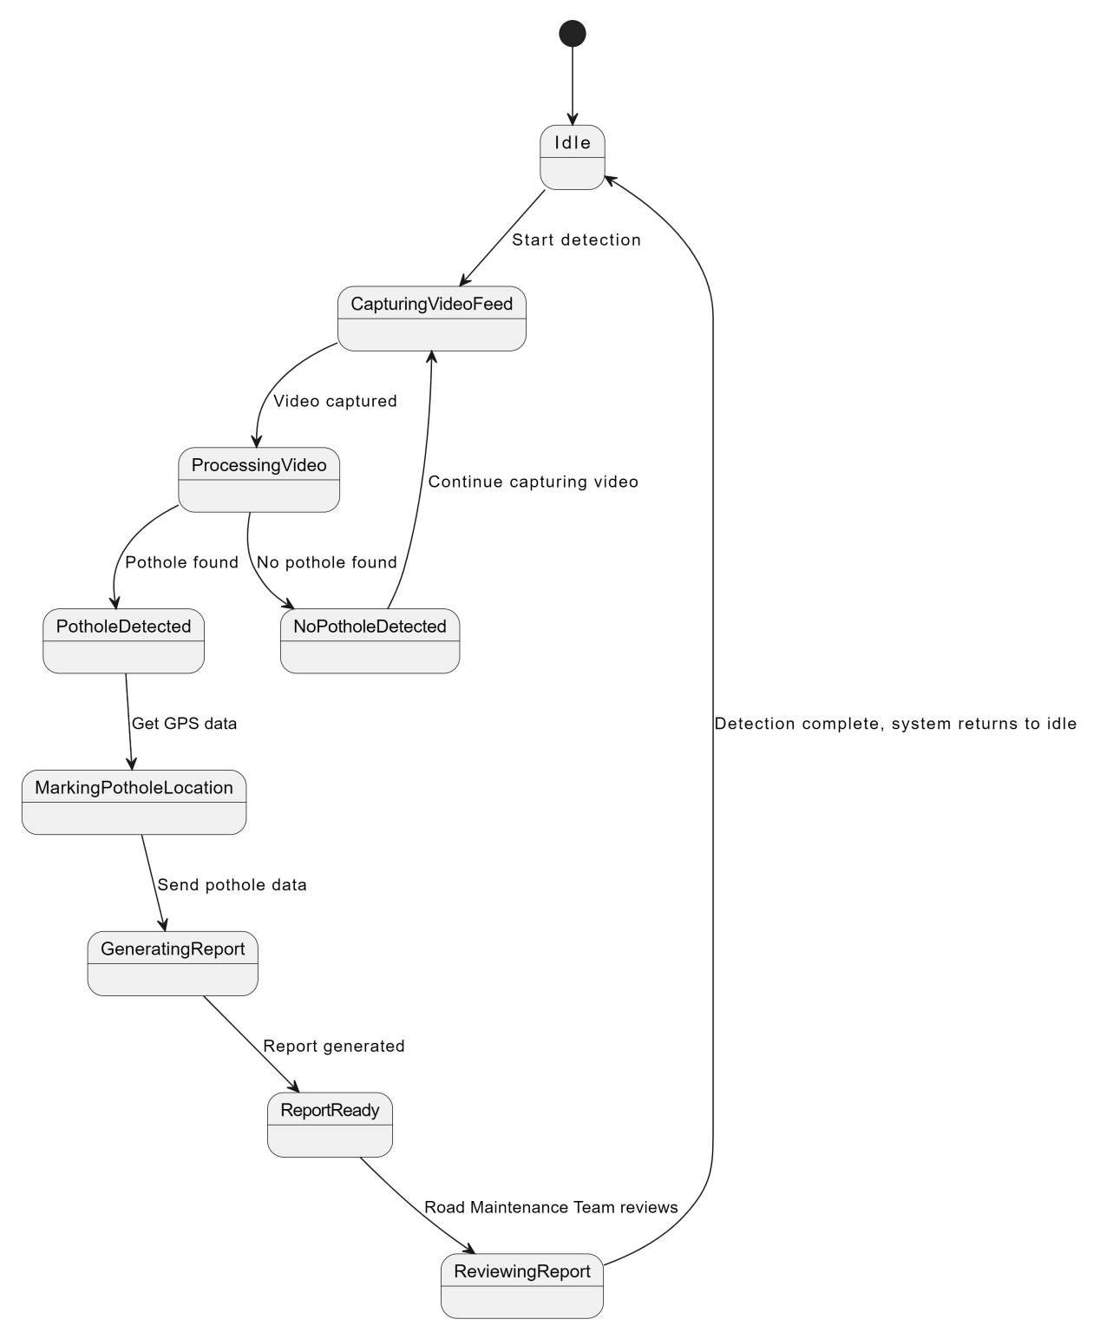

1. **Sequence Diagram:**

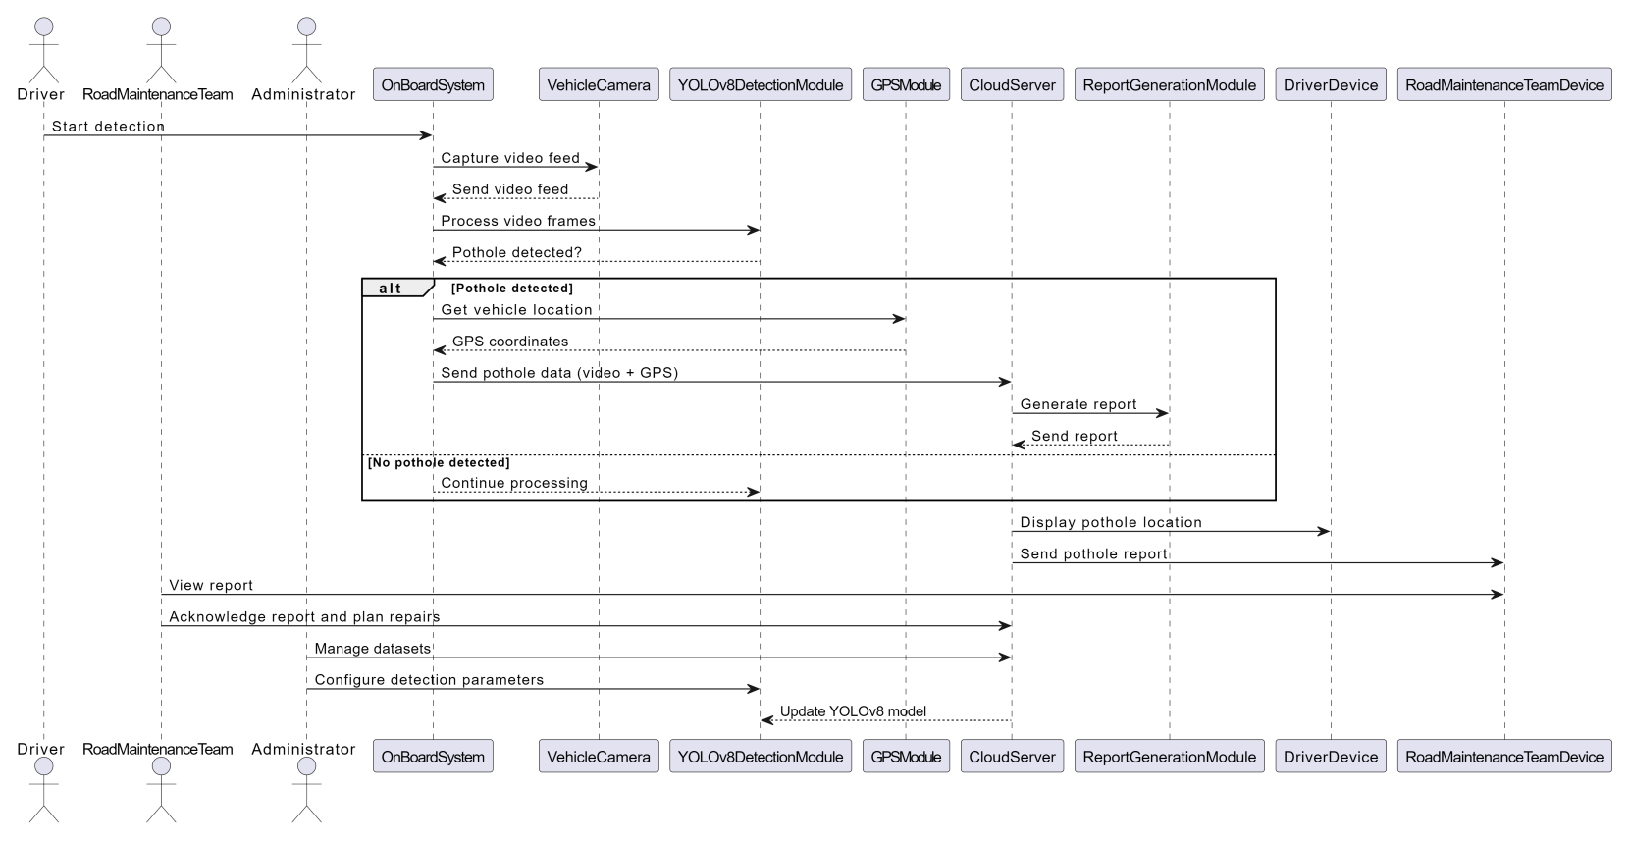

1. **Interaction Diagram:**

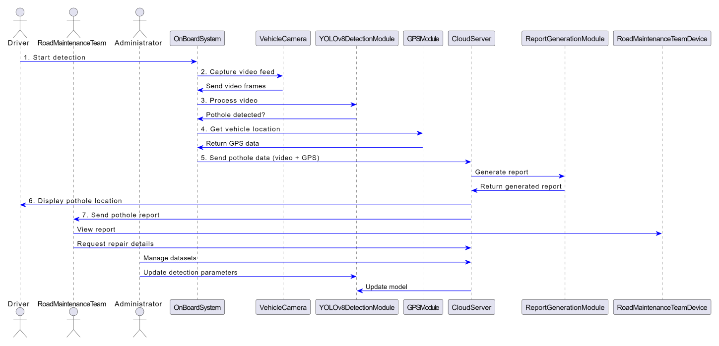

1. **Component Diagram:**

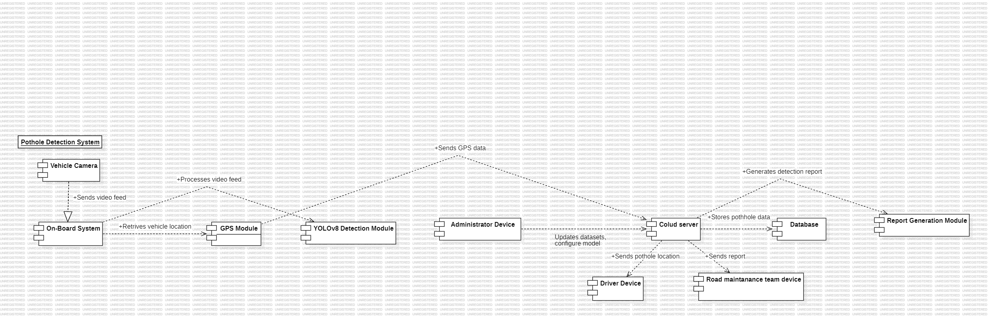

1. **Deployment Diagram:**

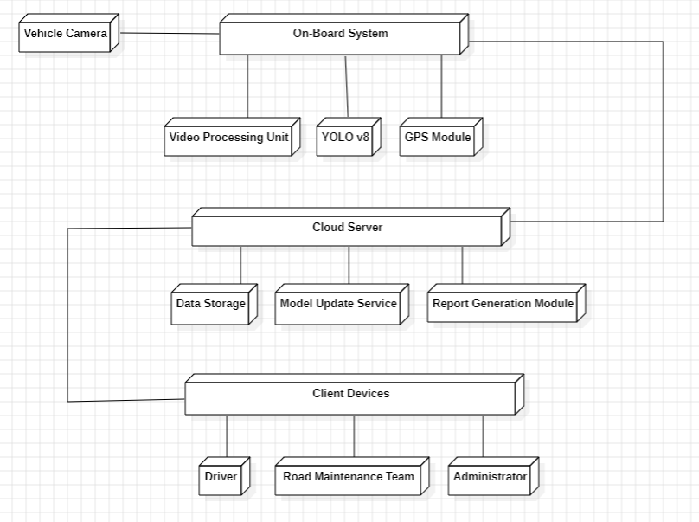

1. **Data Flow Diagram:**

**DFD Level 1:**

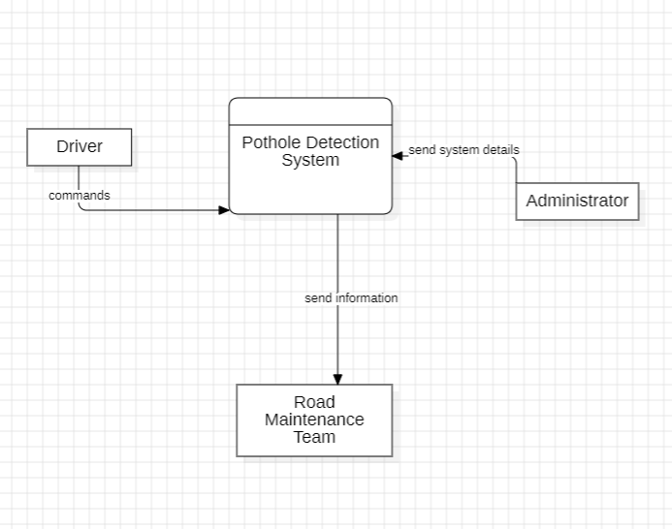

**DFD Level-2:**

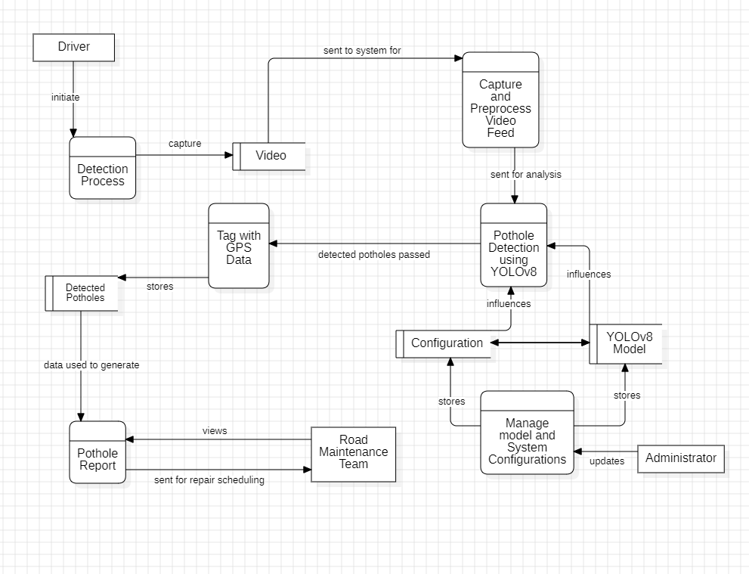

1. **ER Diagram:**

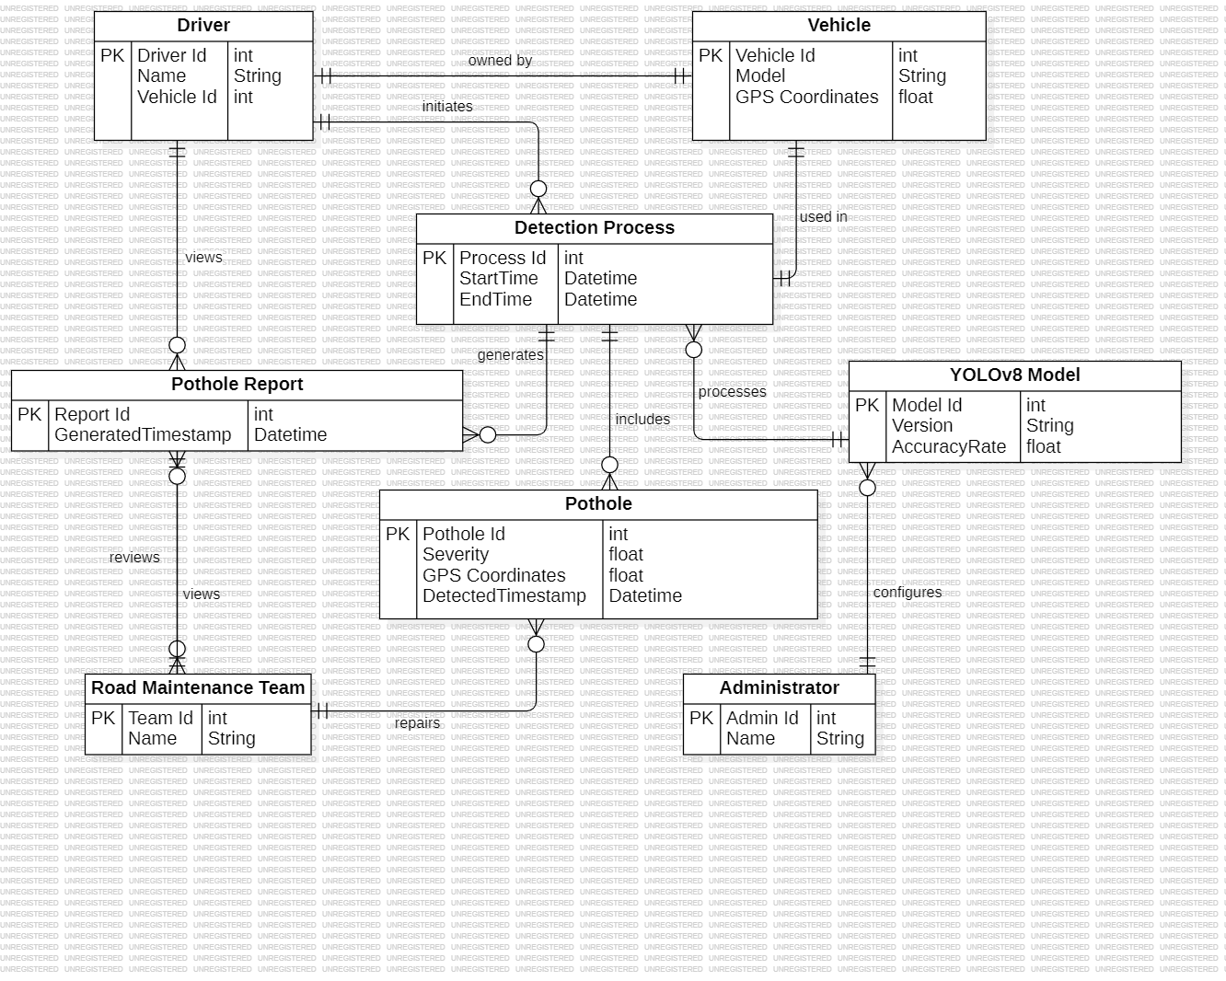

### ****Implementation of Pothole Detection Using YOLOv8****

The implementation of the **Pothole Detection System** using **YOLOv8** focuses solely on detecting potholes from video streams without any additional features like GPS tracking or report generation. The following describes the key steps involved in developing and deploying the system.

**Architecture Block Diagram:**

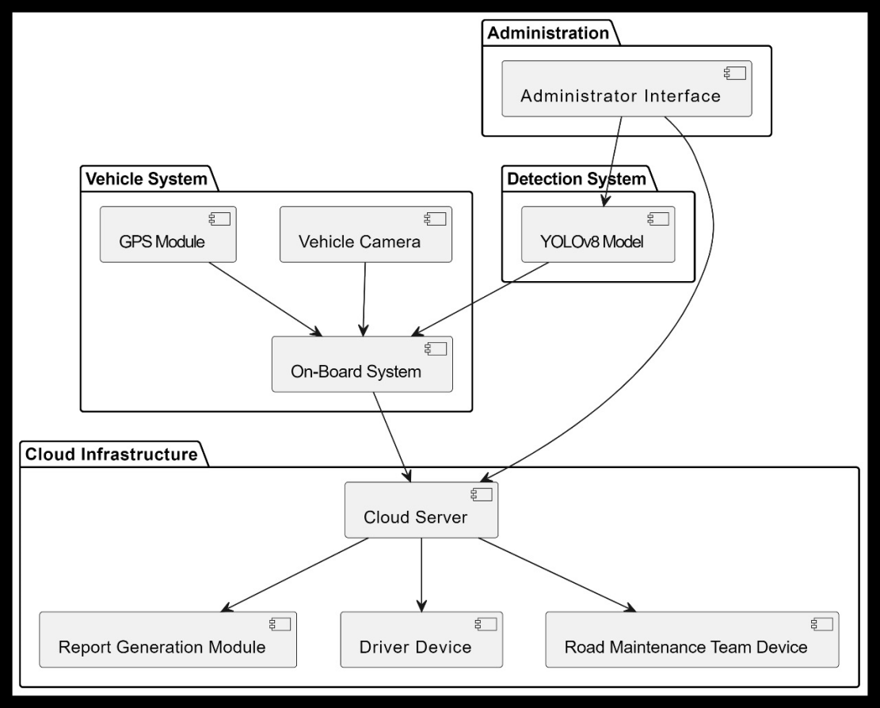

#### 1. ****Dataset Collection and Preparation****

The first step in implementing the pothole detection system involves gathering a high-quality dataset. This includes a mix of images and videos of roads containing potholes from diverse environments (urban, rural, highways) and various conditions (wet, dry, low light). The dataset should be annotated to mark the location of the potholes.

* **Data Sources:** Open-source datasets, manual video collection from vehicle-mounted cameras, and publicly available datasets such as Roboflow.
* **Data Annotation:** Use tools like **LabelImg** to create bounding boxes around the potholes. This annotated data will be used for training the YOLOv8 model.

#### 2. ****Training the YOLOv8 Model****

Once the data is prepared, the next step is to train the YOLOv8 model. YOLOv8 is designed for real-time object detection, which makes it well-suited for detecting potholes in moving vehicles.

**Model Setup:** YOLOv8, being the latest iteration of the YOLO family, has several variants (e.g., YOLOv8-Small, YOLOv8-Medium). For this project, YOLOv8-Small can be used to optimize for faster inference on lower-end hardware without compromising much on accuracy.

**Training Process:**

* + The model is fine-tuned on the annotated dataset using **transfer learning**. Transfer learning allows the model to build on pre-trained weights, speeding up the training process and improving accuracy.
  + Hyper parameters like **learning rate, batch size, and input resolution** are optimized during training to balance between speed and accuracy.

**Model Performance Evaluation:**

* + The model is evaluated using metrics such as **mean Average Precision (mAP)** and **Intersection over Union (IoU)** to measure detection accuracy.
  + The dataset is split into training and validation sets to ensure the model generalizes well to unseen data.

#### 3. ****Real-Time Video Processing****

Once the model is trained, it is deployed for real-time pothole detection using video feeds from vehicle-mounted cameras. The system processes video frames and passes each frame through the YOLOv8 model to detect potholes.

**Frame Preprocessing:** Each video frame is resized and normalized before being fed into the YOLOv8 model. This preprocessing step ensures that the input is compatible with the model's dimensions and enhances detection performance.

**YOLOv8 Inference:**

* + The model processes each frame and outputs bounding boxes around detected potholes.
  + These bounding boxes are displayed on the video feed in real-time, allowing drivers to visually identify potholes.

#### 4. ****System Integration and Optimization****

To ensure that the system performs efficiently in real-time, several optimizations are implemented:

**Model Optimization:**

* + **Quantization** techniques can be used to reduce the size of the YOLOv8 model without significantly affecting accuracy, allowing it to run on edge devices like Raspberry Pi or mobile processors.

**Hardware Requirements:**

* + The system can be deployed on onboard vehicle hardware like NVIDIA Jetson or on a standard laptop with a connected camera. The real-time inference speed can be maintained even on low-power devices.

**FPS (Frames Per Second) Optimization:**

* + The system should be able to process a high number of frames per second (FPS) to provide smooth real-time detection. The target FPS depends on the hardware but should be around 25-30 FPS for smooth video.

#### 5. ****Testing and Validation****

Testing the system in real-world conditions is crucial to ensure robustness.

**Testing Environments:** The system is tested in various road environments and weather conditions to ensure that it performs reliably. This includes testing under low-light conditions, different road textures, and varying vehicle speeds.

**Validation Metrics:** The performance of the pothole detection system is validated based on its **detection accuracy**, **false positive rate**, and **latency** in real-time processing.

#### 6. ****Deployment****

Once validated, the system is deployed in vehicles with onboard cameras. The system continuously processes video feeds, detecting and marking potholes in real-time as the vehicle moves.

* **User Interface:**

A simple graphical interface displays the live video feed, with potholes highlighted in real-time. No additional features like mapping or reporting are required.

**Proposed System:**

In this project, we are developing a pothole detection system using the YOLOv8 deep learning model. The system captures real-time video feed from a camera mounted on a vehicle and processes each frame to detect potholes. The detection process is carried out using YOLOv8, a state-of-the-art object detection model that efficiently identifies objects, in this case, potholes, from the video frames.

The system is designed to function in real-time, ensuring quick and accurate detection of potholes as the vehicle moves. Our implementation focuses purely on pothole detection, with the results being displayed directly to the driver for immediate awareness. There is no integration with GPS or report generation, making it a lightweight solution that focuses solely on the detection process and immediate notification to the driver.

The system has been implemented to process frames on-board and display alerts to the driver when potholes are detected. This approach offers a practical solution for drivers to navigate roads with caution upon detecting a pothole, improving driving safety and vehicle performance.

**Algorithm:**

Step 1: Initialize the system and start the video feed from the vehicle camera.

Step 2: Continuously capture frames from the video feed.

Step 3: For each frame captured:

Step 3.1: Pass the frame through the YOLOv8 model for pothole detection.

Step 3.2: If a pothole is detected in the frame:

Step 3.2.1: Display a warning or pothole alert on the driver's display.

Step 3.3: If no pothole is detected:

Step 3.3.1: Continue capturing and processing frames.

Step 4: End the detection when the vehicle stops, or detection is manually turned off by the driver.

This pseudo code outlines the step-by-step operations of the pothole detection system, which continuously captures video, processes each frame through the YOLOv8 model, and alerts the driver if a pothole is detected.

**OUTCOMES:**

The main contribution of the project is a novel attention based coupled framework for road and pothole segmentation. For both structured and unstructured driving environments, the framework performs well in terms of road segmentation. We explore few-shot learning for pothole detection to attain reasonable accuracy with fewer labeled samples.

1. Display the detected Pothole marked with coloured box.

2. Distance of pothole from the vehicle.

3. Measures of the pothole detected

**RESULTS AND DISCUSSIONS:**

The main contribution of the project is a novel attention based coupled framework for road and pothole segmentation. For both structured and unstructured driving environments, the framework performs well in terms of road segmentation. We explore few-shot learning for pothole detection to attain reasonable accuracy with fewer labeled samples.

1. Display the detected Pothole marked with colored box

**Model Training Results:**

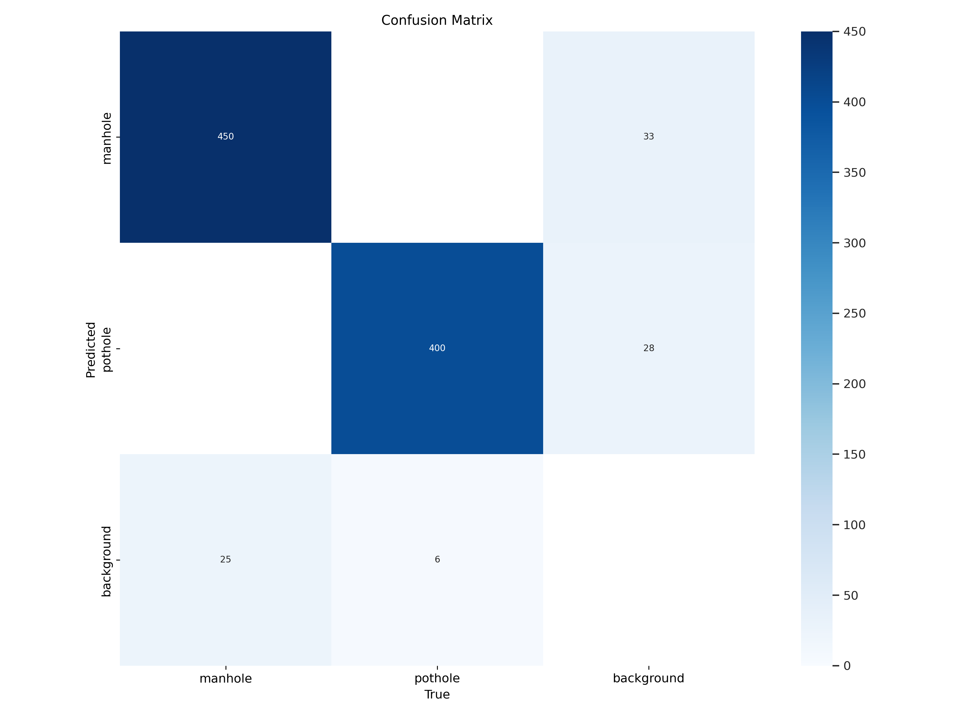

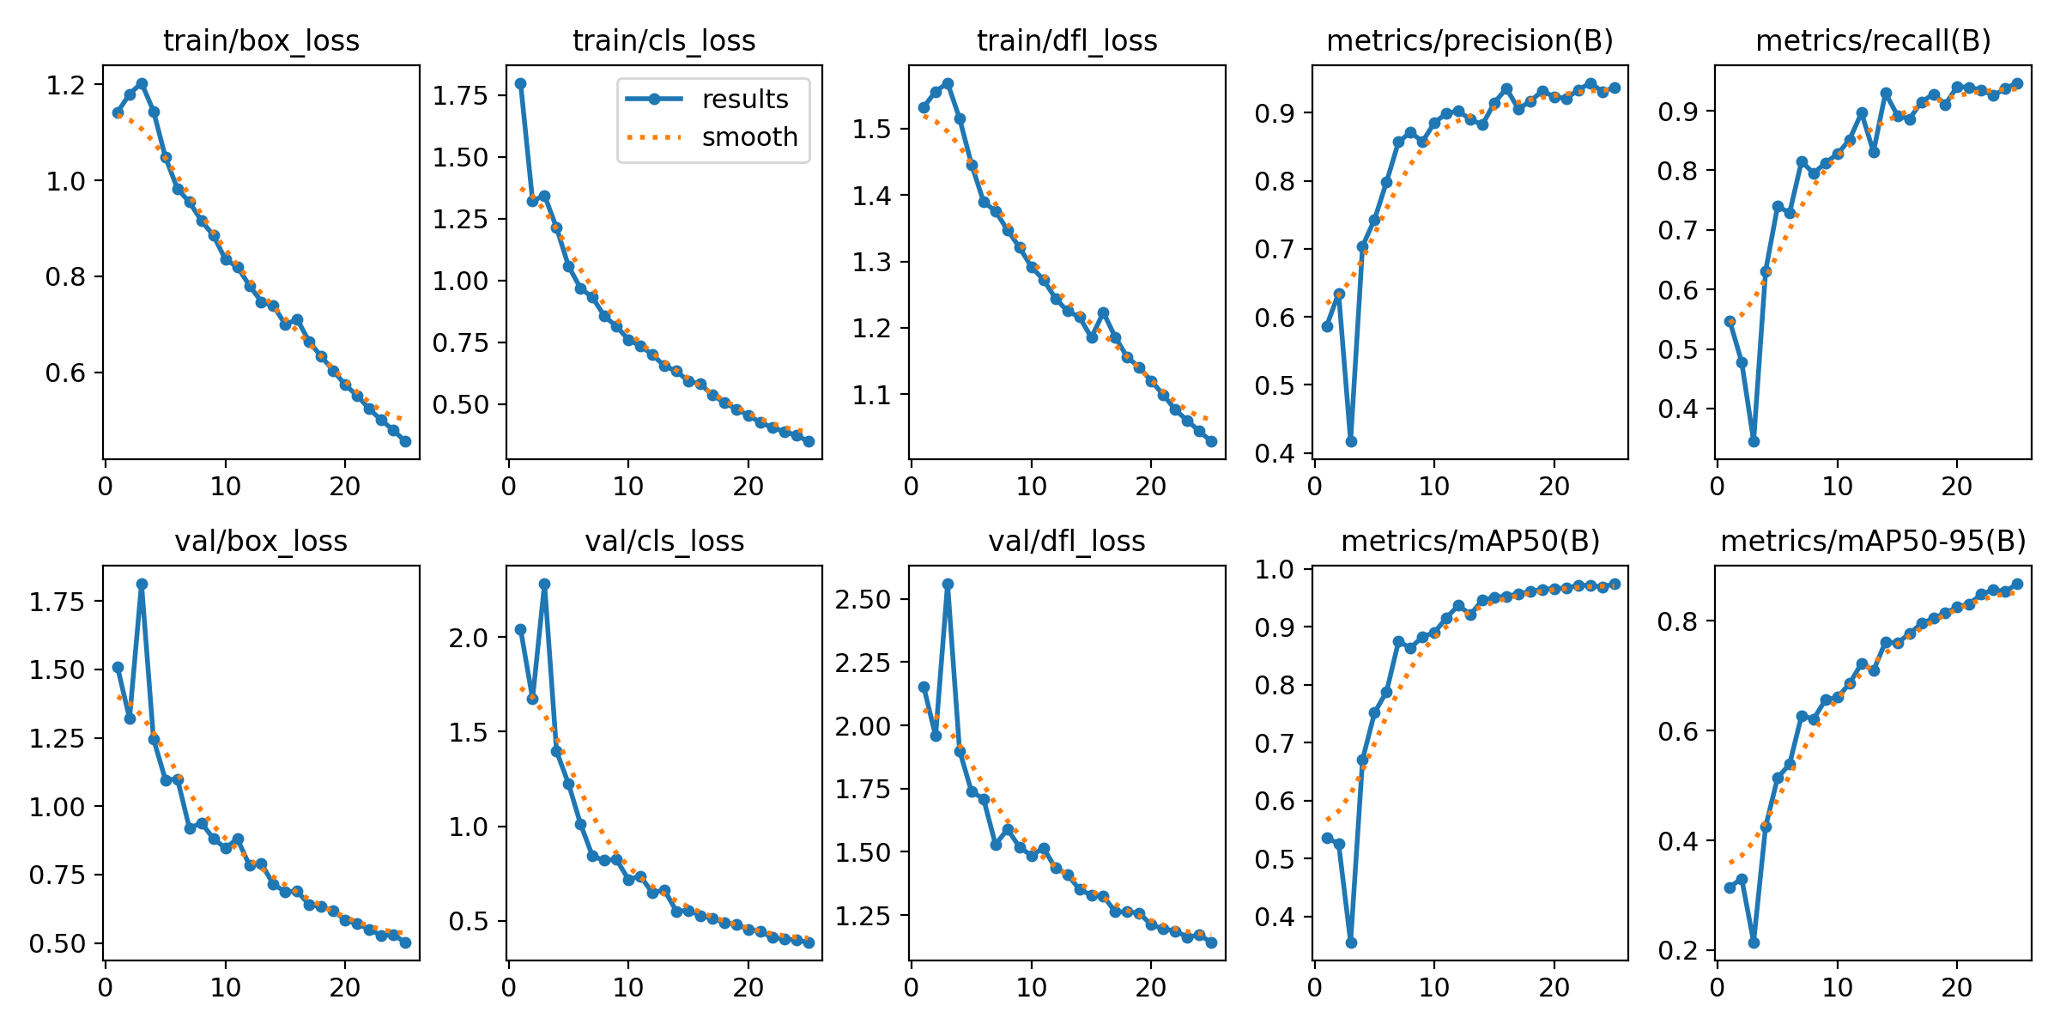

**SCREENSHOTS:**

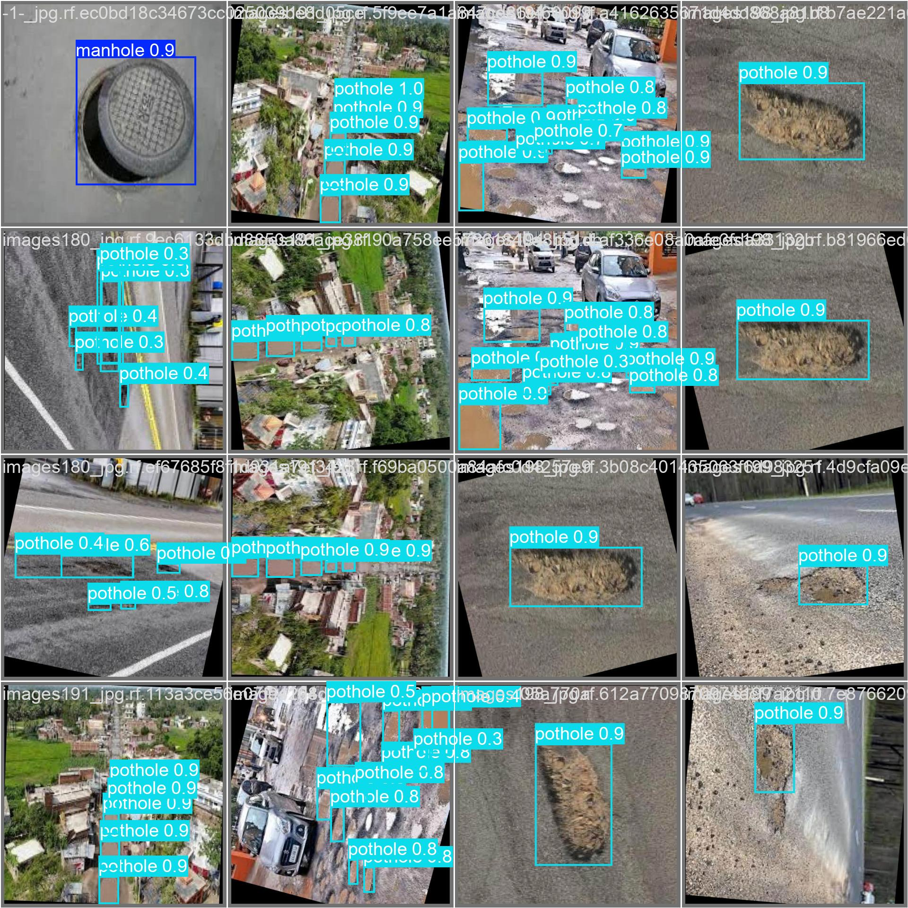

**CONCLUSION:**

In this project, we proposed an efficient method to recognize a pothole on a road from the viewpoint of cost and implementation. This is a handy way because sensor data is acquired using a smartphone everybody has nowadays. To make the implementation easier, we utilized MachineLearning technology which gives us a very flexible way for web application. The interesting thing about this research is that general knowledge works for a specific domain problem. Meanwhile, the success of Machine Learning is dependent on the variety of data which might change according to the sort of vehicles, the shape of bump and pothole, and etc. Many types and shapes mean difficulty of learning, CNN will be helpful to solve it. As a solution we have applied convolutional neural networks to handle the problem well.

**FUTURE SCOPE:**

The main goal of the project of pothole detection has been practically implemented. The prototype that is built is primitive; there is always scope for future improvements which can be in the hardware as well as software part. The following ideas can be considered for the future expansion of the model: Maps can be included in the android application for graphically showing the pothole location. Along with the existing voice notification There is pothole nearby go slow, Distance of the pothole can also be voice notified. A more complex prototype can be developed so as to control the speed of the vehicle when there is a pothole ahead. A more accurate and complex algorithm can be used to find the distance between two latitudes and longitudes.

**References:**

* + [1] O. o. I. R. a. Development, "Distress Identification Manual for the Long- TermPavement Performance Project," U.S Department of Transportation Federal Highway Administration, 2014.
  + [2] I. G. V. P. Heggie, "Commercial Management and Financing of Roads," WorldBank, Washington, 1998.
  + [3] A. M. Legreid, "Potholes and Strategies on the Road to Campus Internationalization," International Research and Review: Journal of Phi Beta DeltaHonor Society for International Scholars, vol. 6, no. 1, 2016.
  + [4] A. F. Rita Justo-Silva, "Pavement maintenance considering traffic accidentcosts," International Journal of Pavement Research and Technology, 2019.
  + [5] S.-K. R. Taehyeong Kim, "A Guideline for Pothole Classification,”International Journal of Engineering and Technology, vol. 4, 2014.
  + [6] B. X. Yu and X. Yu, "Vibration-Based System for Pavement Condition Evaluation," in Applications of Advanced Technology in Transportation, 2006.
  + [7] K. D. Zoysa, G. P. Seneviratne, W. W. A. T. Shihan and C. Keppitiyagama, "A Public Transport System Based Sensor Network for Road Surface Condition Monitoring," in SIGCOMM07: ACM SIGCOMM 2007 Conference, Kyoto, 2007.

[8] L. G. B. H. R. N. S. M. H. B. Jakob Eriksson, "The Pothole Patrol: Using aMobile Sensor Network for Road Surface Monitoring," inMobisys08: The 6thInternational Conference on Mobile Systems, Applications, and Services, Breckenridge, 2008.

* + [9] K. C. P. Wang, "Challenges and Feasibility for Comprehensive Automated Survey of Pavement Conditions," in Eighth International Conference on Applications of Advanced Technologies in Transportation Engineering (AATTE), Beijing, 2004.
  + [10] K. T. Chang, J. R. Chang and J. K. Liu, "Detection of Pavement Distresses Using 3D Laser Scanning Technology," in International Conference on Computing in Civil Engineering 2005, Cancun, 2005.
  + [11] Z. Hou, K. C. Wang and W. Gong, "Experimentation of 3d Pavement Imaging Through Stereovision," in International Conference on Transportation Engineering 2007, Chengdu, 2007.
  + [12] C. Koch and I. Brilakis, "Pothole detection in asphalt pavement images," Advanced Engineering Informatics, vol. 25, no. 3, pp. 507- 515, 2011.
  + [13] G. M. Jog, C. Koch, M. Golparvar-Fard and I. Brilakis, “Pothole Properties Measurement through Visual 2D Recognition and 3D Reconstruction," in International Conference on Computing in Civil Engineering, Florida, 2012.
  + [14] L. Huidrom, L. K. Das and S. Sud, "Method for automated assessment of potholes, cracks and patches from road surface video clips,” Procedia - Social and Behavioral Sciences, vol. 104, pp. 312-321, 2013.
  + [15] Aparna, Y. Bhatia, R. Rai, V. Gupta, N. Aggarwal and A. Akula, "Convolutional neural networks based potholes detection using thermal imaging," Journal of King Saud University – Computer and Information Sciences, 2019.
  + [16] A. Bianchini, P. Bandini and D. W. Smith, "Interrater Reliability of Manual Pavement Distress Evaluations," Journal of Transportation Engineering, vol. 136, no. 2, pp. 165-172, 2010.
  + [17] O. Mendoza, P. Melin and G. Licea, "A New Method for Edge Detection in Image Processing using Interval Type-2 Fuzzy Logic," in 2007 IEEE International Conference on Granular Computing, California, 2007.
  + [18] T. Kim and S.-K. Ryu, "Review and analysis of pothole detection methods," Journal of Emerging Trends in Computing and Information Sciences, vol. 5, no. 8, pp. 603-608, 2014.
  + [19] A. Bhat, P. Narkar, D. Shetty and D. Vyas, "Detection of Potholes using Image Processing Techniques," IOSR Journal of Engineering, vol. 2, pp. 52-56, 2018.
  + [20] M. Muslim, D. Sulistyaningrum and B. Setiyono, "Detection and counting potholes using morphological method from road video," AIP Conference Proceedings, vol. 2242, no. 1, pp. 3-11, 2020.